Locations of ibm.com and wipro.com
Admin Name: IBM Corporation
Admin Organization: International Business Machines (IBM)
Admin Street:
Admin City: Armonk
Admin State/Province: NY
Admin Postal Code: 10598
Admin Country: US
Admin Phone: +1.9147654227
Admin Phone Ext:
Admin Fax: +1.9147654370
Admin Fax Ext:
Admin Email: dnsadm@us.ibm.com

Admin Name: Wipro Ltd.
Admin Organization: Wipro Ltd.
Admin Street: Doddakannelli
Admin City: Bangalore
Admin State/Province: Karnataka
Admin Postal Code: 560035
Admin Country: IN
Admin Phone: 18002007068
Admin Phone Ext:
Admin Fax: +91.9999999999
Admin Fax Ext:
Admin Email: domain.admin@wipro.com

Mail servers of ibm.com and wipro.com

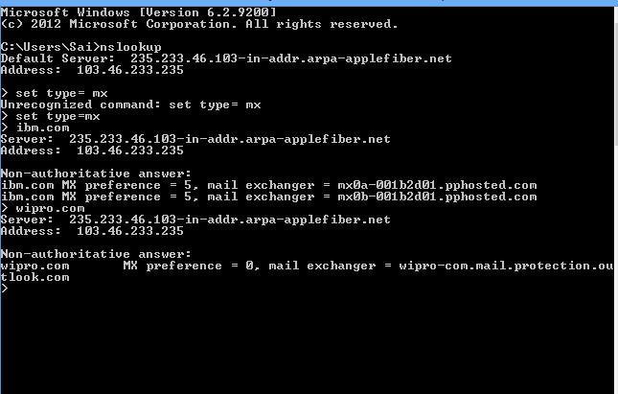

Open ports of given network is
